**HW Week 9-Ind: UX Examples**

Name: Aarjav Dutt

Describe your three favorite products that have great design and three that you like the least (have terrible design). Consider both digital and physical products. Include pictures/screen shots of those products and explain why you think design is great or terrible.

**Great Design Examples**

1. Splitwise: One of a good design product, which I have been using since a long time is Splitwise. It makes splitting bills and keeping up with balances very easy. It has replaced the conventional methods of writing each transaction with every friend on paper or a notepad or splitting a bill among my friends convenient.

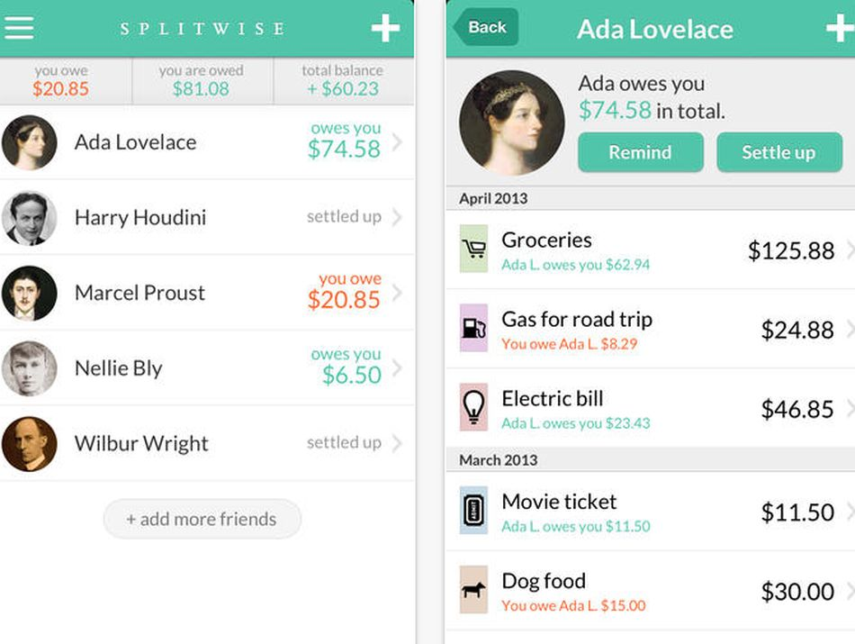

1. Amazon Echo: Amazon series of echo products is another example of good design. Just 4 buttons on the interface to control the features of Alexa. It is a perfect example of a simple UI, where a user, be it an amateur or a techie, can manage to operate on the product and interact with Alexa within seconds of unboxing it.

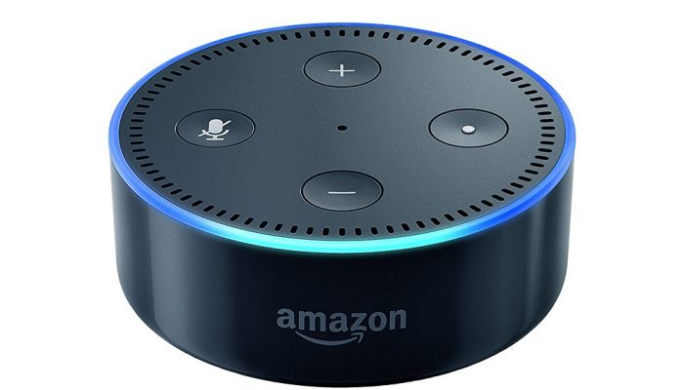

1. Uber: With the ease of ordering a cab online to ordering your favorite food from the App. Uber has been a boon for consumers since 2009. Users can order the ride with the click of one button, they can track their ride as it comes to the pickup point. There is no hassle of booking a cab in advance or calling a cab while its arriving. Uber is a fine example of good designs.

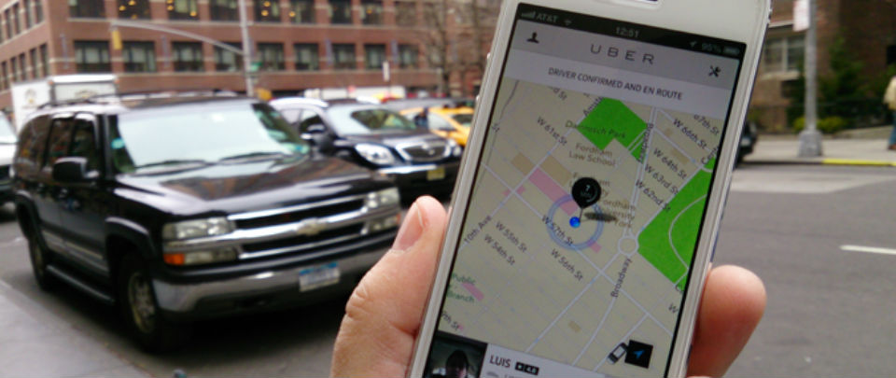

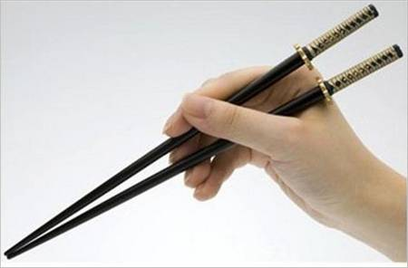**Terrible Design Examples**

1. Chopsticks: For me personally, it took a great ordeal to practice eating from chopsticks. But for an unpracticed person, who is going to a Chinese restaurant, it may be difficult to eat by chopsticks. It might have a sophisticated design, But the highly difficult usability makes it a bad design.
2. 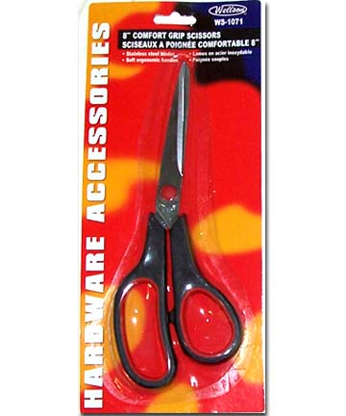Clamshell Packed Scissors: It may be the worst ideas to pack a product built for opening packages, so tightly packaged in a clamshell, that one may need another pair of scissors or cutting equipment to open it. Not a good user-friendly product.
3. Touch Bar on Macbook: On of the brilliant designs from Apple, although it is very innovative and unconventional design, it is of very less utility. The functions that are displayed on the touch bar are only enabled when you perform specific operations, and moreover it gives you only those options which are already given on the screen. According to me it is a bad design.

